SCHOOL OF COMPUTER SCIENCE AND ARTIFICIAL INTELLIGENCE |  |  |  |  | DEPARTMENT OF COMPUTER SCIENCE ENGINEERING
ProgramName:B. Tech |  |  |  | SET-B |  |  | AcademicYear:2025-2026
Roll No.
Instructor(s)Name |  |  |  | - Dr. Venkataramana  - Dr. Ch. Sridhar  - Mr. Kundan Kumar
CourseCode |  |  | 24CS002PC215 | CourseTitle |  | AI Assisted Coding
Year/Sem |  |  | II/I | Regulation |  | R24
Date and Day  of Assignment |  |  | 22.08.2025 | Time(s) |  | 01.00PM To 03.00PM
Duration |  |  | 2 Hours | Applicableto  Batches |  | 24BTCAIAIB09, 24BTCAIAIB10
Lab Test :1(Present test number)/4(Total number of tests)
 | Q.No. | Question |  |  |  |  |  | ExpectedTime  to complete
 | 1 | Task Description#1  - Write python program for a function factorial_febo(n) that return both factorial of given number and Fibonacci series as per input “n”  Expected Output#1  - factorial_febo(n) and output  Prompt: Write python program using functions (factorial_febo(n)) that return both factorial of given number and Fibonacci series.  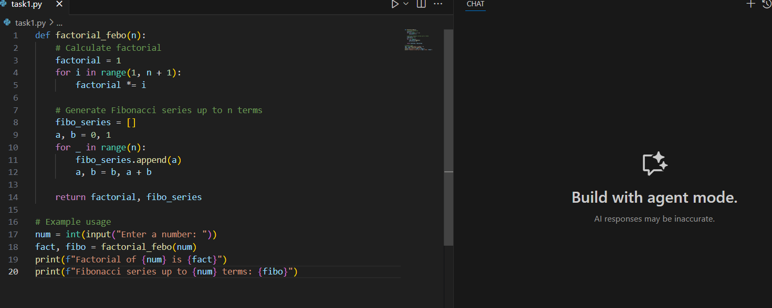  Output:  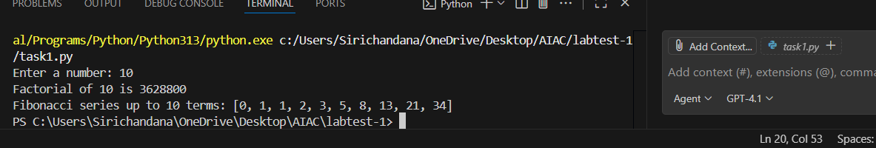  Explanation: In this we used functions to generate the factorial and the Fibonacci series. when the number is given by the user the code will display the factorial and the Fibonacci series.  Task Description#2  - Write Python program in cursor AI for student class with attributes like Name, Roll no, Marks and also construct a method i.e., display_details to display name, rollno, marks and grades  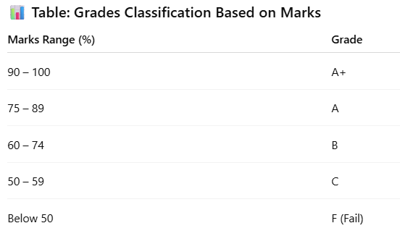  Expected Output#2  - Student Class and Display Details  Prompt: Write a python program for student class with attributes like Name ,Roll no, Marks and grades (90-100 grade(A+),75-89 grade(A),60-74 grade(B),50-59 grade(C),below 50 grade(F) and also display the details using sorting functions (display_details)  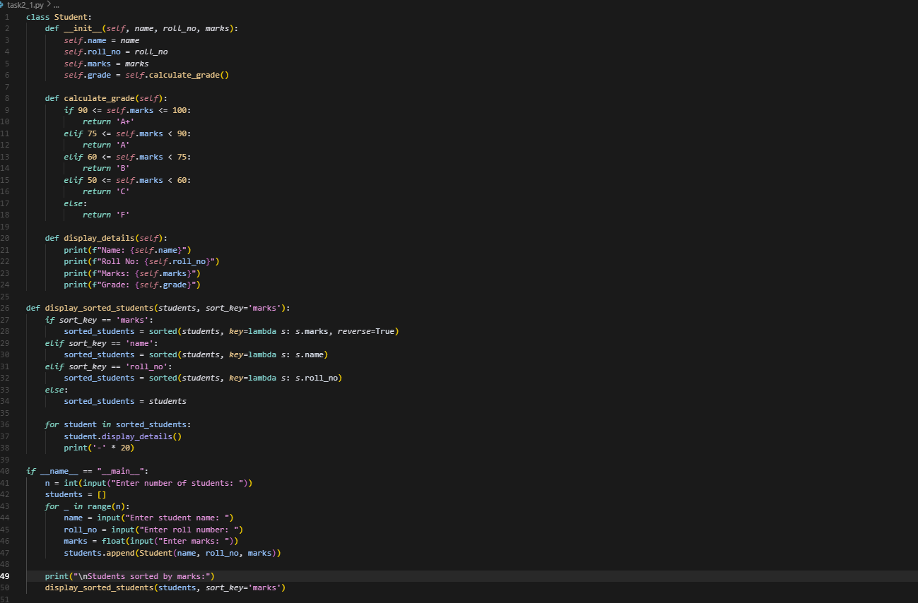  Output:  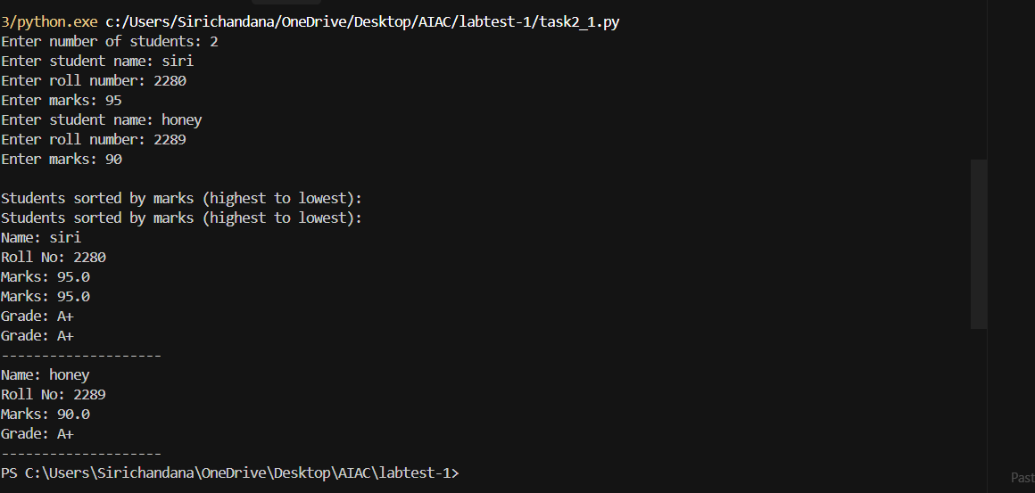  Explanation: This code is to display the details of the student for that with the help of sorting functions this code is used to display the content which we gave to the student using python.  Note: Report should be submitted a word document for all tasks in a single document with prompts, comments & code explanation, and output screenshots  Evaluation Criteria:  Criteria Max Marks  Factorial Function (Task#1) 5  Sorting Function (Task#2) 5  Viva 5  Total 15 Marks |  |  |  |  |  | 22.08.2025 03.00PM

